ASSIGNMENT NO.8: Views and Data Abstraction
Student Name | Aditya Ballal | Roll Number | 20966
Batch | SY. BSc Data Science | Topic | WB(Assignment-8)

Questions:
Q1) Create a MySQL database named CollegeDB and create two tables: Course and Student.
Course Table
Column Name | Data Type | Constraint
CourseID | INT | PRIMARY KEY
CourseName | VARCHAR(50) | NOT NULL
Fees | DECIMAL(10,2) | NOT NULL
Student Table
Column Name | Data Type | Constraint
StudentID | INT | PRIMARY KEY
StudentName | VARCHAR(50) | NOT NULL
CourseID | INT | FOREIGN KEY
City | VARCHAR(30)
Marks | INT
Email | VARCHAR(60)
Insert at least 4 course records and 10 student records.
CREATE DATABASE CollegeDB8;
USE CollegeDB8;

CREATE TABLE Course (
CourseID INT PRIMARY KEY,
CourseName VARCHAR(50) NOT NULL,
Fees DECIMAL(10,2) NOT NULL
);

CREATE TABLE Student (
StudentID INT PRIMARY KEY,
StudentName VARCHAR(50) NOT NULL,
CourseID INT,
City VARCHAR(30),
Marks INT,
Email VARCHAR(60),
FOREIGN KEY (CourseID) REFERENCES Course(CourseID)
);

INSERT INTO Course (CourseID, CourseName, Fees) VALUES
(101, 'BSc IT', 45000.00),
(102, 'BCA', 40000.00),
(103, 'BSc CS', 42000.00),
(104, 'Data Science', 55000.00);

INSERT INTO Student (StudentID, StudentName, CourseID, City, Marks, Email) VALUES
(1, 'Rahul Sharma', 101, 'Mumbai', 78, 'rahul@gmail.com'),
(2, 'Priya Patil', 102, 'Pune', 85, 'priya@gmail.com'),
(3, 'Aman Verma', 103, 'Nashik', 67, 'aman@gmail.com'),
(4, 'Sneha Joshi', 101, 'Mumbai', 91, 'sneha@gmail.com'),
(5, 'Karan Mehta', 102, 'Thane', 74, 'karan@gmail.com'),
(6, 'Neha Shah', 101, 'Pune', 88, 'neha@gmail.com'),
(7, 'Rohan Desai', 103, 'Mumbai', 69, 'rohan@gmail.com'),
(8, 'Meera Kulkarni', 102, 'Nashik', 82, 'meera@gmail.com'),
(9, 'Arjun Nair', 101, 'Thane', 59, 'arjun@gmail.com'),
(10, 'Divya More', 102, 'Mumbai', 93, 'divya@gmail.com');
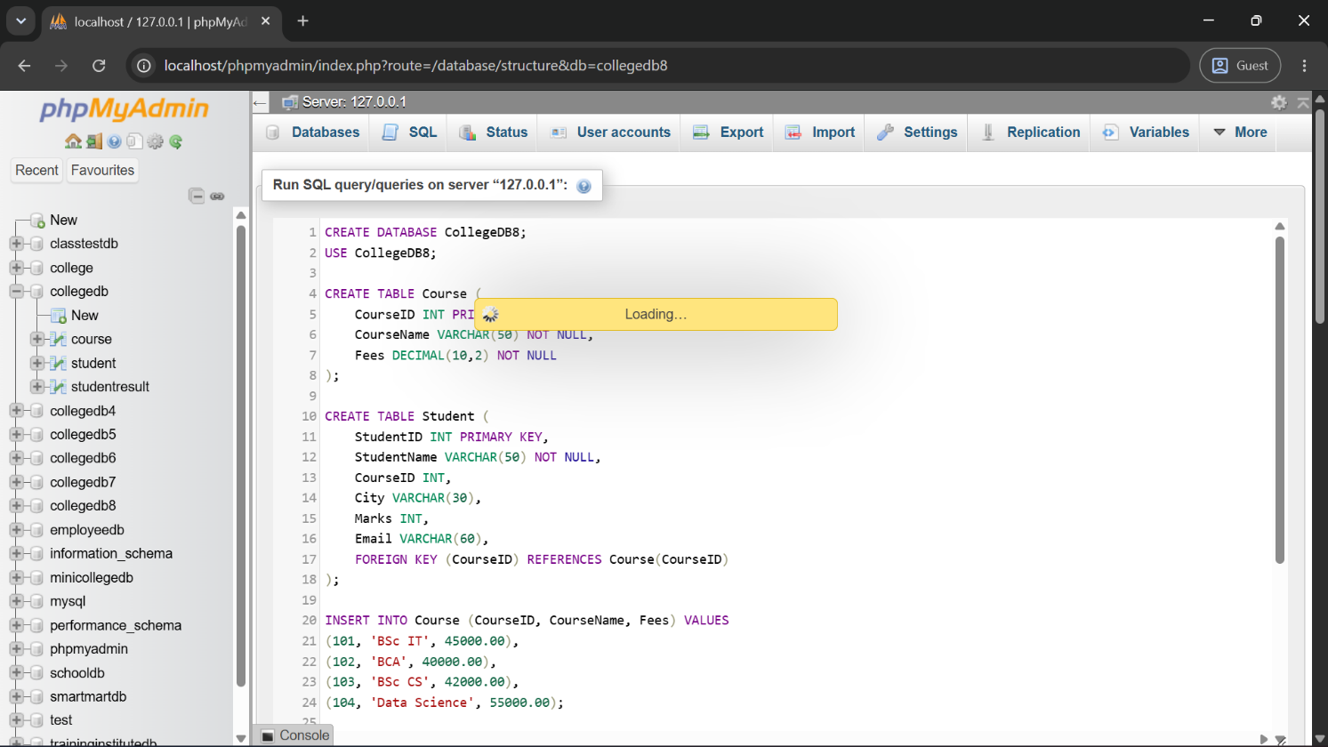
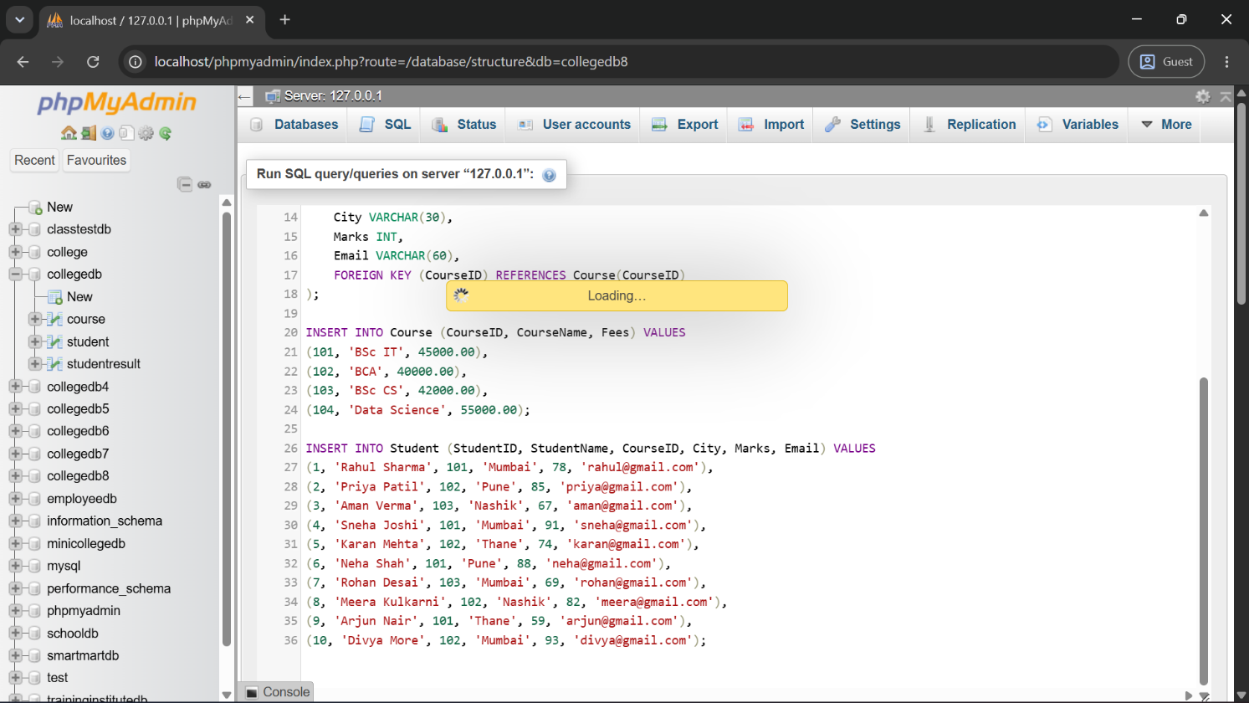
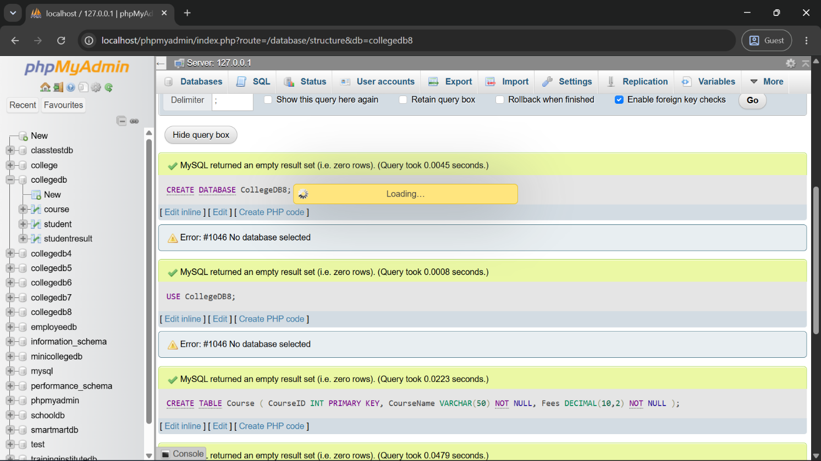
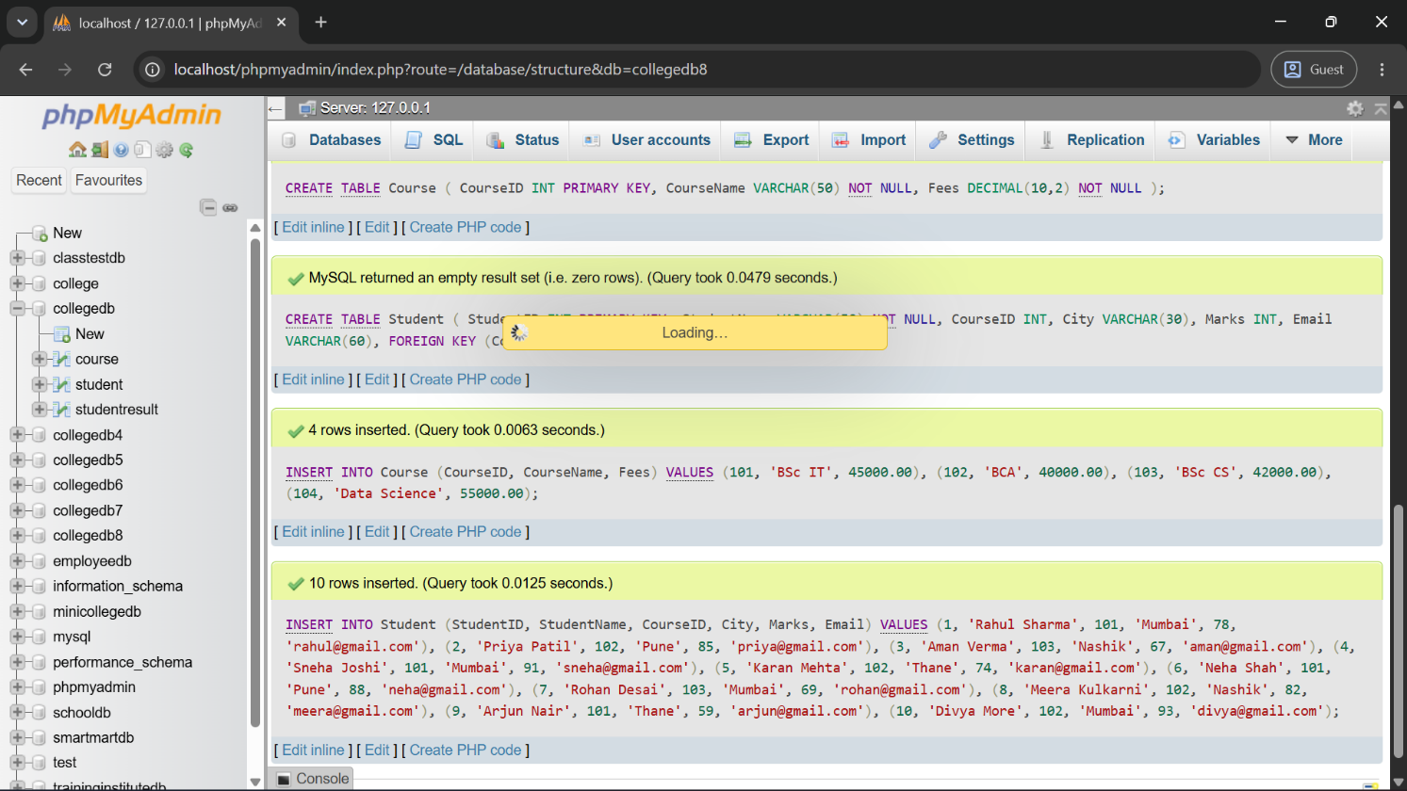
Q2) Create a view named StudentBasicView to display only selected student details.
The view should contain:
Column
StudentID
StudentName

Column
City
Marks
Query:
CREATE VIEW StudentBasicView AS
SELECT StudentID, StudentName, City, Marks
FROM Student;
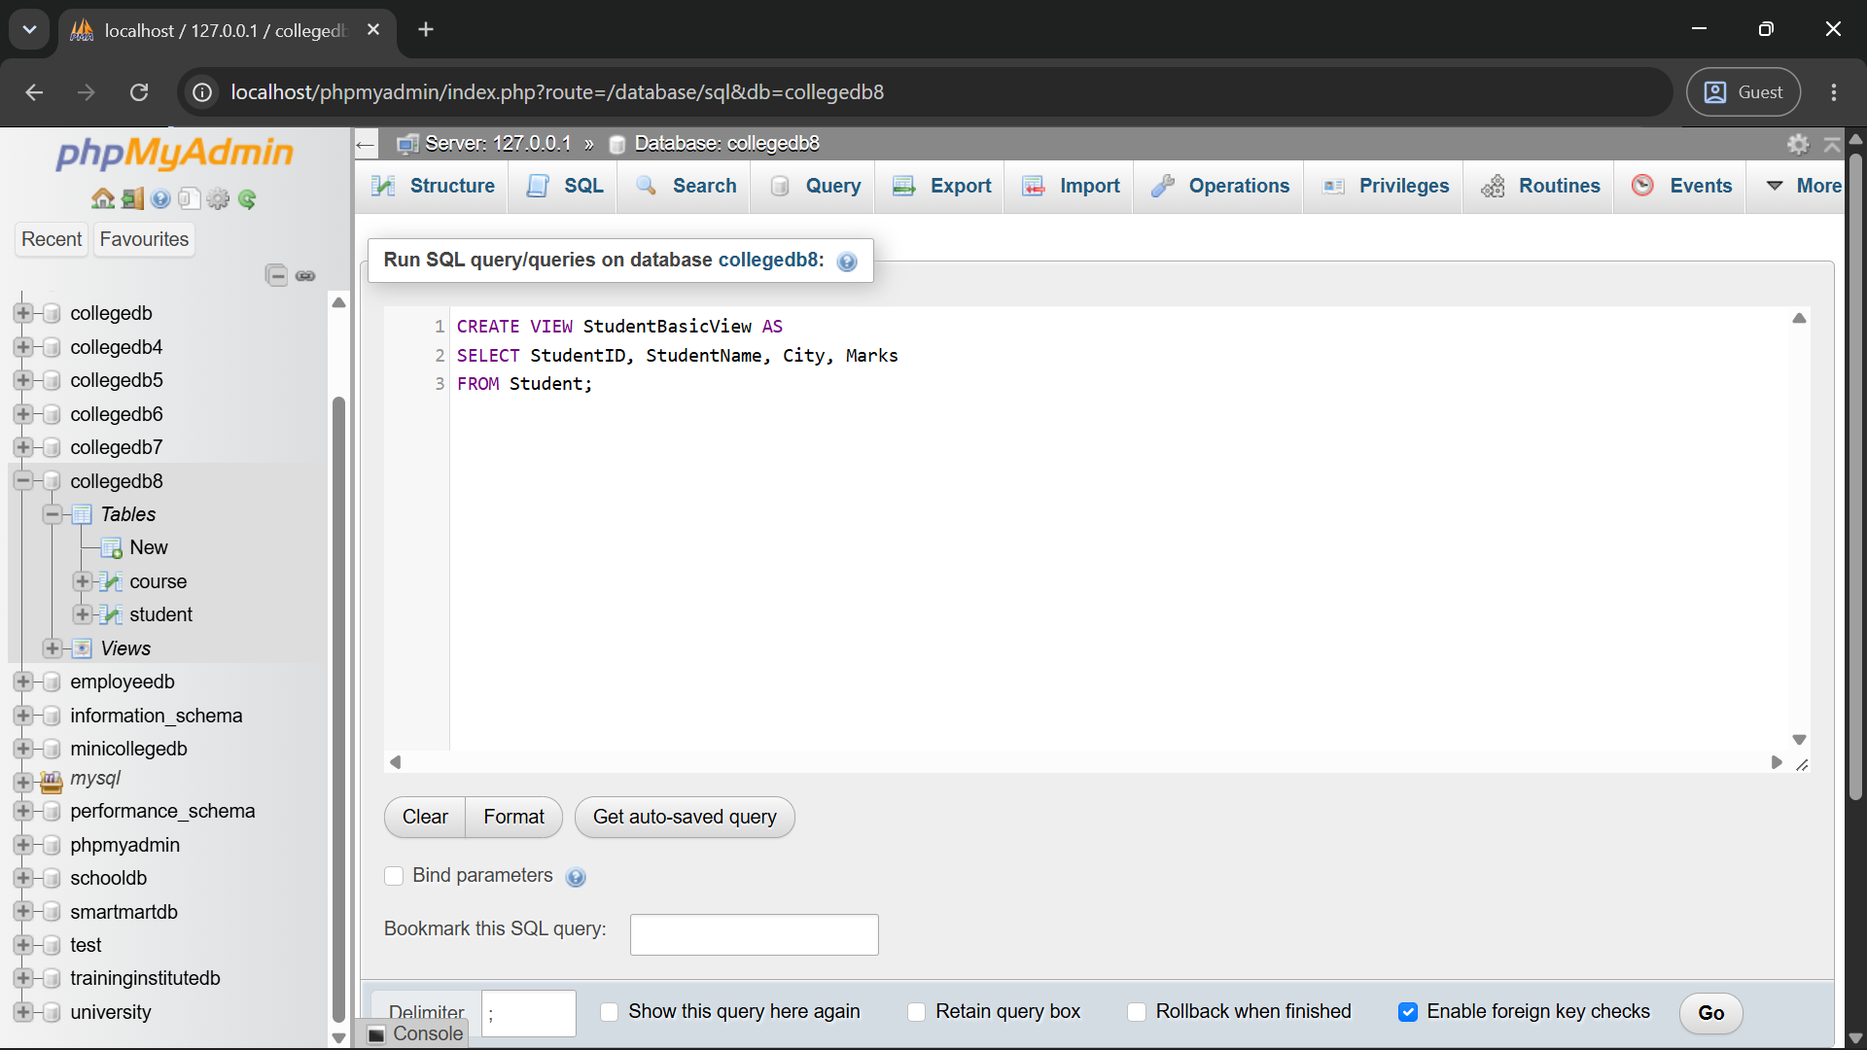
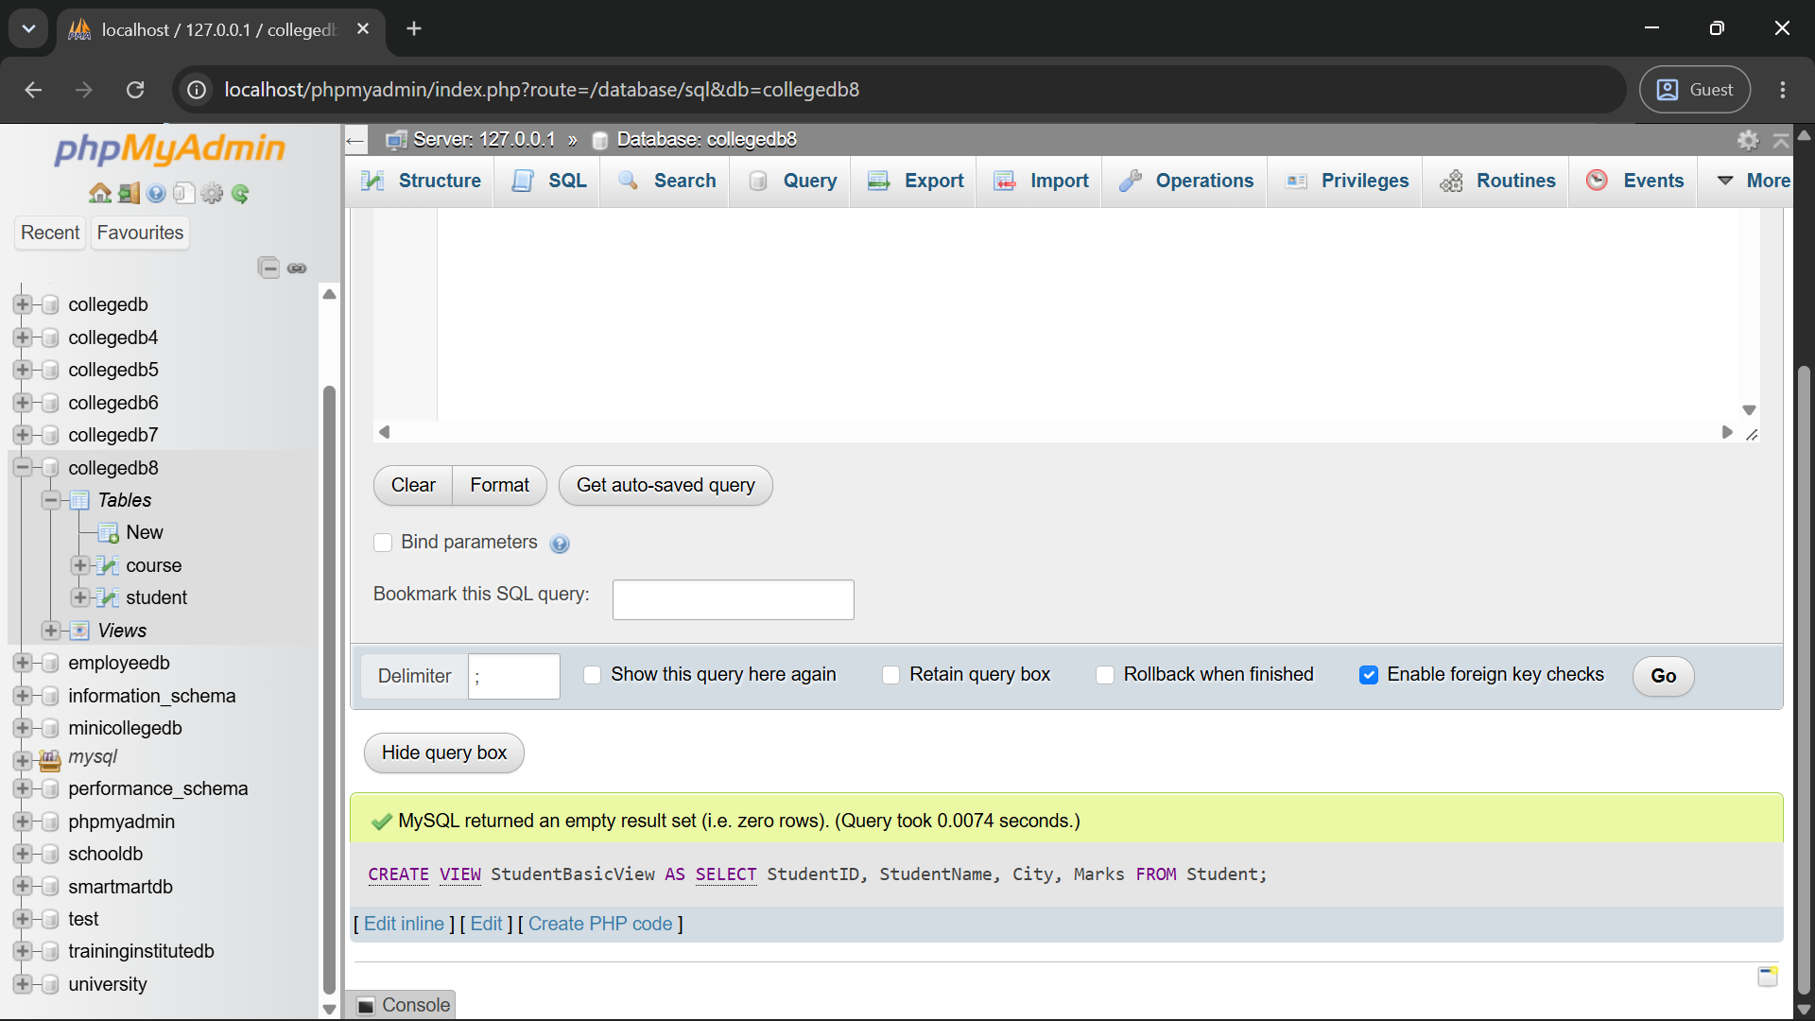
Q3) Create a view named StudentCourseView using Student and Course tables.
The view should display:
Column
StudentID
StudentName
City
Marks
CourseName
Fees
Query:
CREATE VIEW StudentCourseView AS
SELECT Student.StudentID, Student.StudentName, Student.City, Student.Marks, Course.CourseName, Course.Fees
FROM Student
INNER JOIN Course ON Student.CourseID = Course.CourseID;
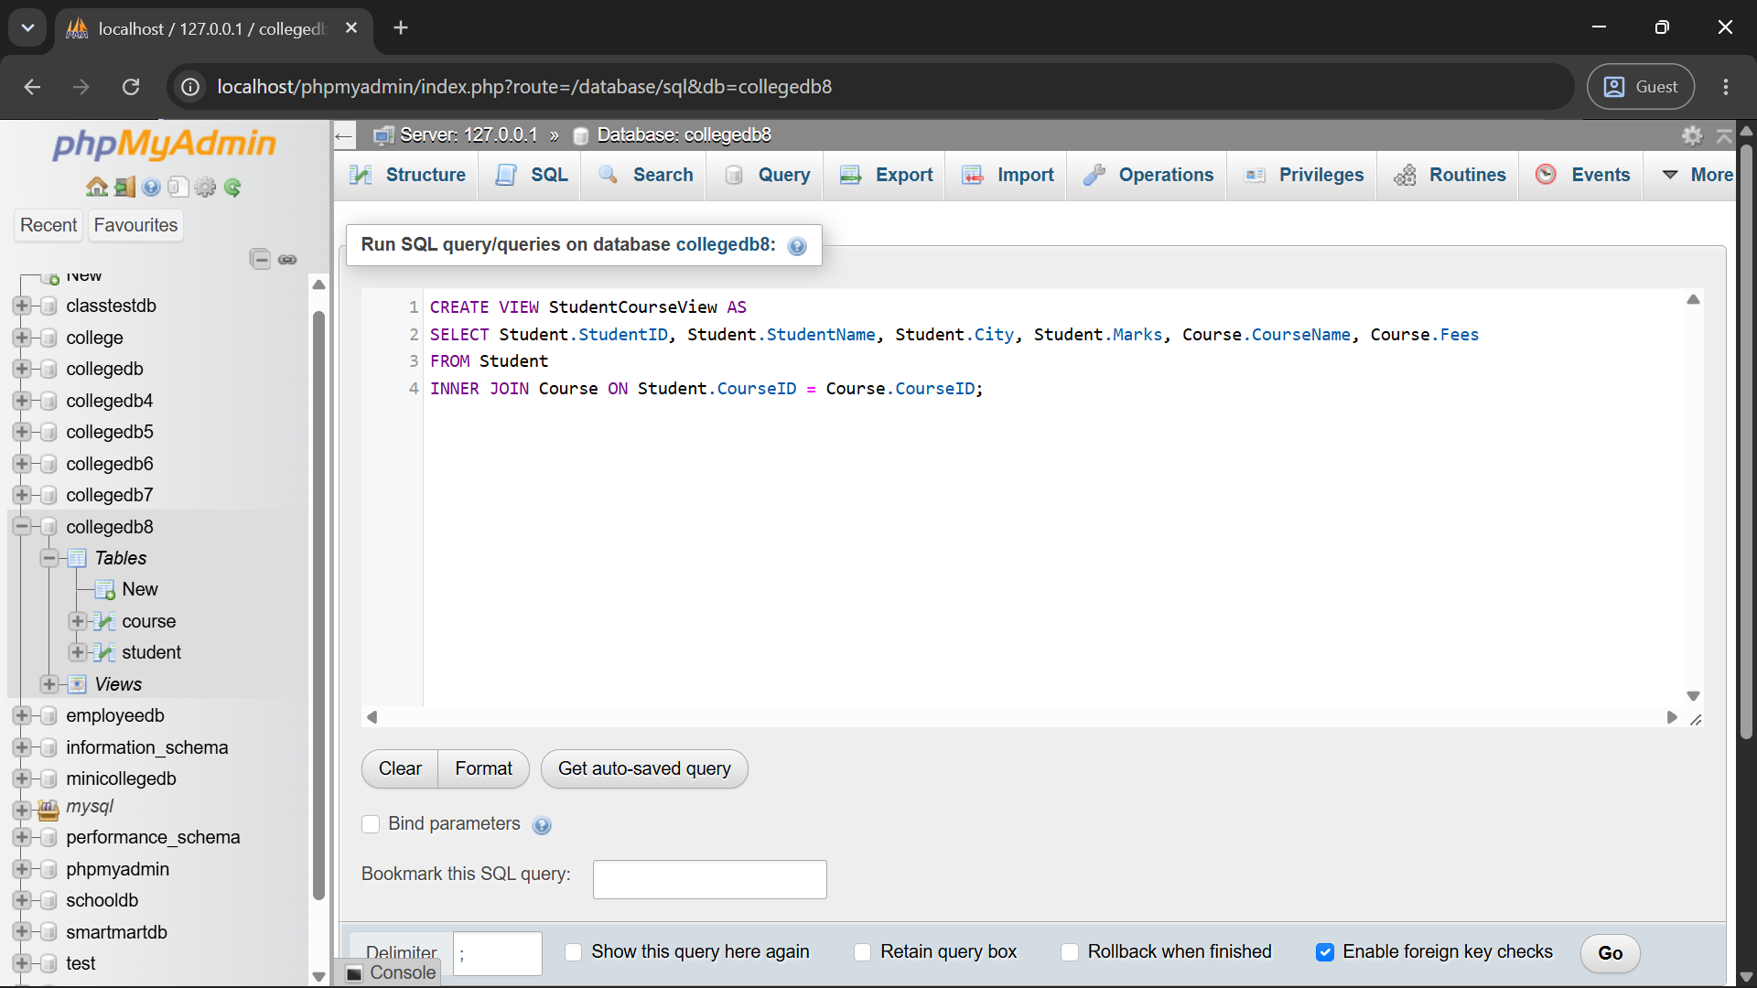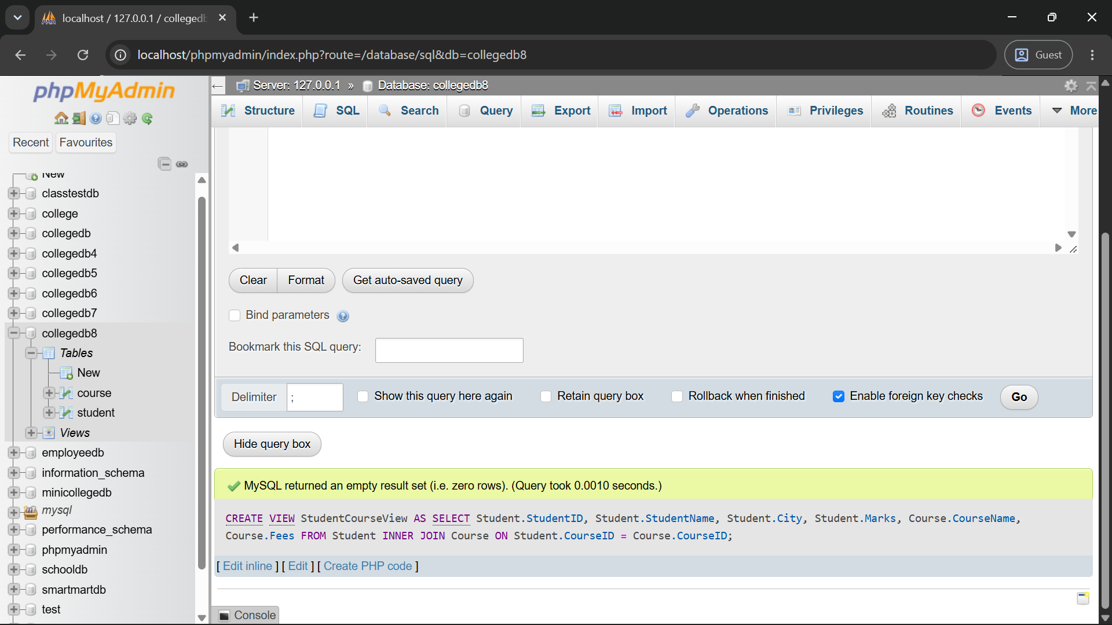
Q4) Write a MySQL query using StudentCourseView to display students from Mumbai.
The output should contain:
Column
StudentName
City
CourseName
Marks
Query:
SELECT StudentName, City, CourseName, Marks
FROM StudentCourseView
WHERE City = 'Mumbai';
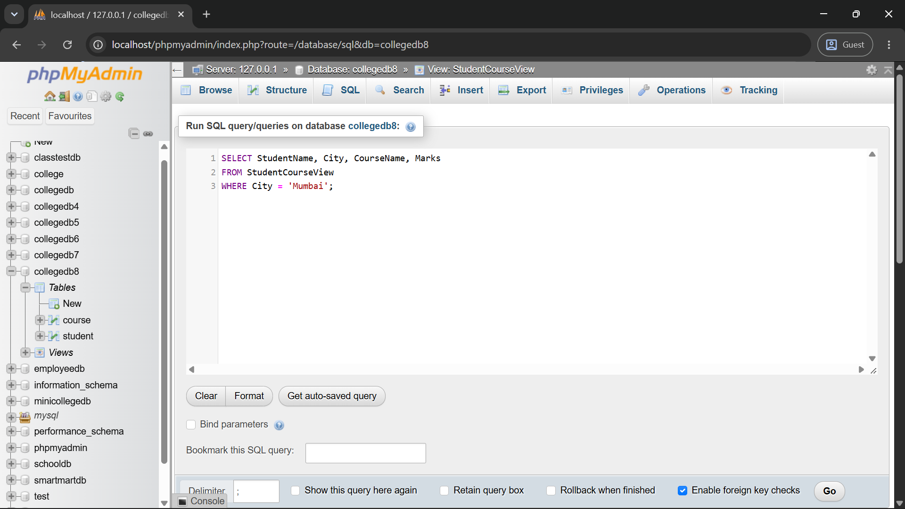
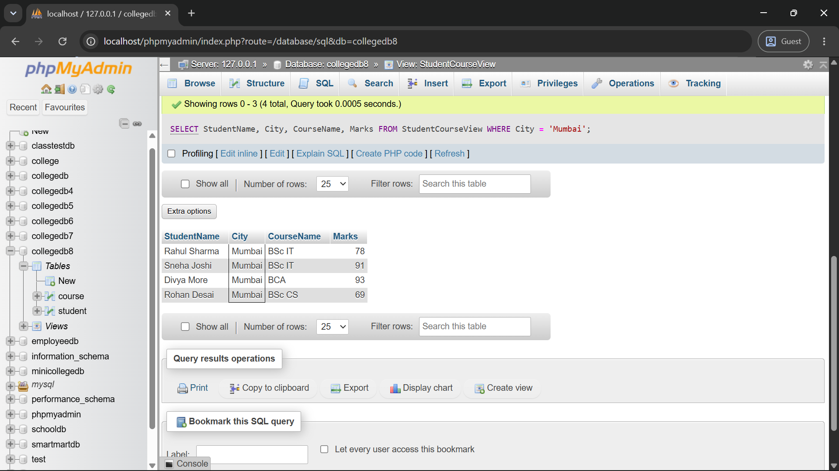
Q5) Write a MySQL query using StudentCourseView to display students sorted by marks in descending order.
The output should contain:
Column
StudentName
CourseName
Marks
Query:
SELECT StudentName, CourseName, Marks
FROM StudentCourseView
ORDER BY Marks DESC;
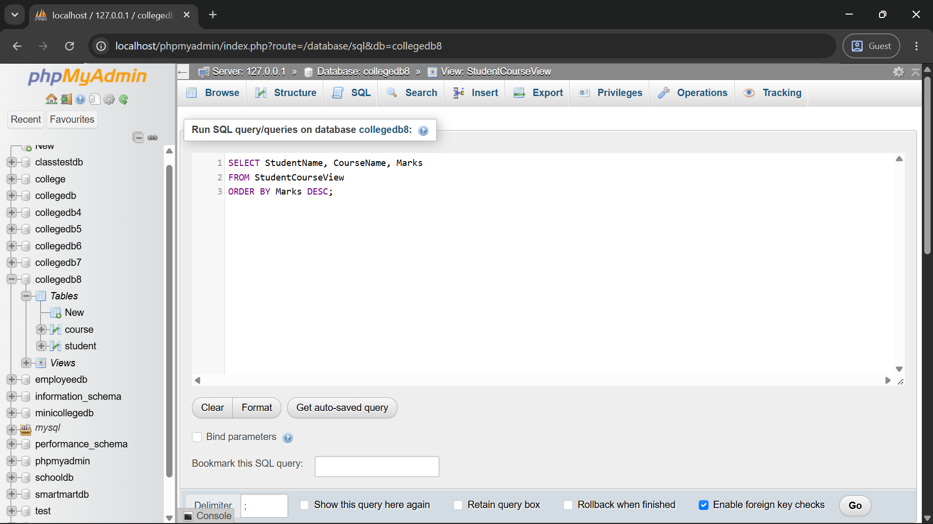
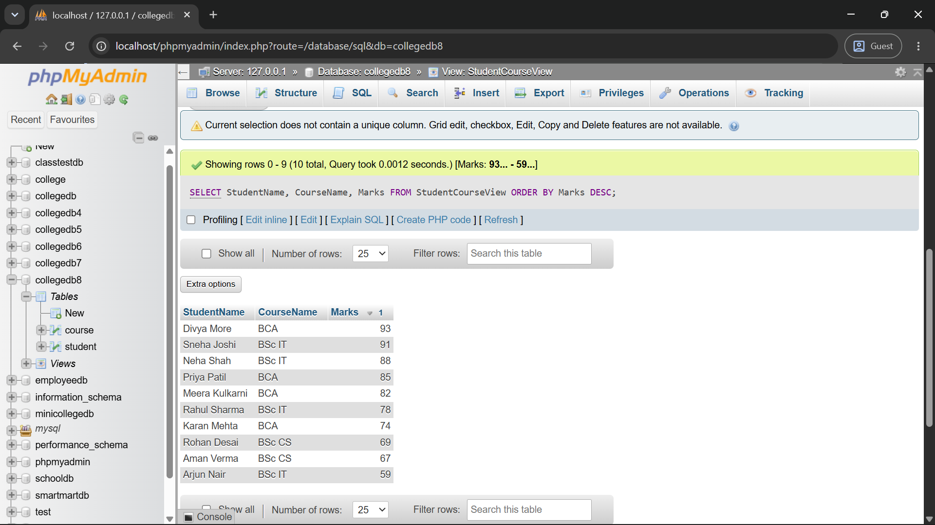
Q6) Create a report view named ManagementReportView.
The view should display course-wise summary:
Column
CourseName
TotalStudents
AverageMarks
LowestMarks
HighestMarks
Query:
CREATE VIEW ManagementReportView AS
SELECT Course.CourseName,
COUNT(Student.StudentID) AS TotalStudents,
AVG(Student.Marks) AS AverageMarks,
MIN(Student.Marks) AS LowestMarks,
MAX(Student.Marks) AS HighestMarks
FROM Course
LEFT JOIN Student ON Course.CourseID = Student.CourseID
GROUP BY Course.CourseName;
